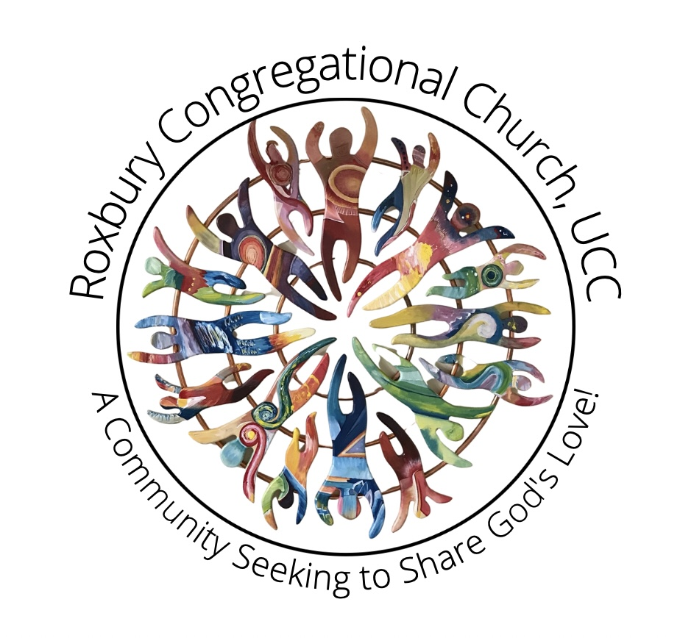
Roxbury Congregational Church
A Congregation in the United Church of Christ
24 Church Street ~ Roxbury, Connecticut 06783
860-355-1978 ~ office@roxburychurch.org
www.roxburychurch.org

We Are a Community Seeking to Share God’s Love!

The Rev. David F. Peters Sandra L. Kleisner
Minister Minister of Music
david@roxburychurch.org sandra@roxburychurch.org

October 24, 2022

Dear Members and Friends of the Roxbury Congregational Church,

The coming holiday season reminds us to be thankful for God’s gift to us in the birth of Christ. As the new year approaches, our church is ever mindful of our mission statement, which is: “We Are a Community Seeking to Share God’s Love”. We continue to participate in mission projects such as the Daily Bread Food Pantry, Loaves and Fishes Soup Kitchen, and many more.

The pandemic has not stopped us! In-person church services have resumed, along with Zoom and Facebook Live.

God is ever faithful. We are grateful to all of you who continue your generous financial support which enables our outreach ministry can be vibrant and nimble, as well as providing for the ministries that we share. Let us now come together and look to the new year knowing we are blessed and can be a blessing.

Please return the enclosed pledge form by November 13 (Stewardship Sunday) so that we may have a great start to the stewardship campaign and quickly meet our goal. You can also find an electronic version of the pledge form at roxburychurch.org/give.

May our vision of 2023 be clear: to be present to all who need us, to share God’s love and continue to inspire us all to be a part of it.

Peace be with you.

The Stewardship Committee,

Michael Wilcox, Brian Neff, Susan Stauffacher

